## The Bicycle Lane Tool

The Bike Lane tool works similarly to tools like the Polyline and the Road tool. The bike image can be changed from a Standard (as shown below) to a Shared lane symbol in Properties.

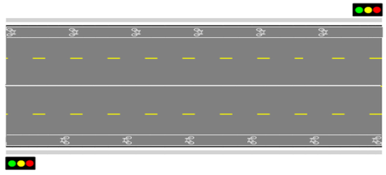

Bike_Lanes_on_a_Road

**To place the bike lane:**

* Select the **Bike Lane** tool from the Infrastructure tab in the Tools Palette.
* Click to start the bike lane.
* Hold **SHIFT** to create a straight lane, or click to create control points to adjust the lane’s shape.
* Right click to finish.